Draft Minutes of OASIS TOSCA TC Meeting

URL OF CALENDAR EVENT:
https://www.oasis-open.org/apps/org/workgroup/tosca/event.php?event_id=54570

DATE: 21. 3, 2024
TIME: 5:00 pm CET
Scribe: Damian A. Tamburri (PoliMi - JADS)

Meeting was quorate: YES

Observers: N/A

Roster

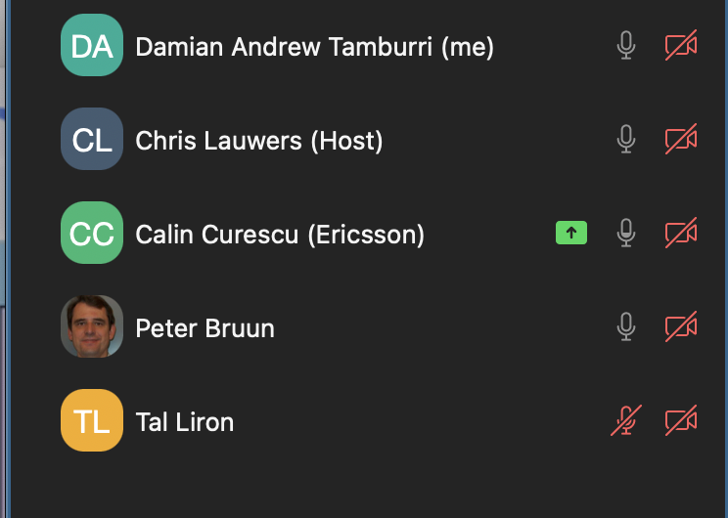

Approval of Minutes
Chris motions to approve the minutes as posted - Seconded by Damian. Motion PASSES by unanimous consent.

Approved Agenda:
Chris makes a motion to approve the proposed agenda as posted, seconded by Tal. Motion PASSES by unanimous consent.

Other Motions and Results (broken out from below):
No other Motions Reported.

Motion to Adjourn:
MOTION to adjourn by Chris. Seconded by Tal. Motion PASSES by unanimous consent. Meeting adjourned at 5:31 PM CET.

Raw Chat Log:

anonymous morphed into Chris Lauwers (Chair)

Chris Lauwers (Chair): MEETING WEB CONFERENCE AND PHONE BRIDGE: Hello and welcome to today's meeting of the TOSCA TC! Please note that we are using Zoom as our web conferencing facility. The link to the Zoom meeting is:
https://groups.oasis-open.org/events/event-description?CalendarEventKey=b0ce3e12-f0e2-46c7-8fa8-dc1eaaa33cc0&CommunityKey=f9412cf3-297d-4642-8598-018dc7d3f409

ATTENDANCE RECORDING: Participants are responsible for logging their attendance on the TC calendar event page. When you join the meeting, use this page to record your attendance by clicking "RSVP". If you are not on the internet during the meeting, you can verbally request the Chairs to record your attendance on your behalf during the meeting.

TODAY'S TC CALENDAR EVENT PAGE
https://www.oasis-open.org/apps/org/workgroup/tosca/event.php?event_id=54570

LEAVES OF ABSENCE:
(Please send requests to TC mailing lists (CC Chairs) at least one week in advance. Must specify start/stop dates.)
- None -

REGRETS RECEIVED:
- None -

Thanks to our TC Secretary, Damian Tamburri!
============================

TOSCA-teers! While you are waiting, please check out and contribute to the following:
A.OASIS github repository with drafts of the TOSCA specifications:
https://github.com/oasis-tcs/tosca-specs
B.TOSCA github repository with contributions from the TOSCA community: https://github.com/oasis-open/tosca-community-contributions
C.TOSCA github open issues: https://github.com/oasis-open/tosca-community-contributions/issues
D.TOSCA github WIKI: Information regarding IMPLEMENTATIONS at https://github.com/oasis-open/tosca-community-contributions/wiki/Known-TOSCA-Implementations
E.TOSCA OASIS WIKI: Information regarding PUBLICATIONS AND BLOG POSTS at https://wiki.oasis-open.org/tosca/academic-papers-blog-posts
F.TOSCA LINKEDIN GROUP at https://www.linkedin.com/groups/8505536:
a.REFER our LINKEDIN GROUP to customers and colleagues!
b.LIKE what is there!
c.COMMENT!
d.CONTRIBUTE some news/updates/discussion!

============================

Chris Lauwers (Chair): Approval of Agenda / Approval of Minutes
Review/approve draft proposed agenda
Review/approve draft minutes.
February 15, 2024: https://groups.oasis-open.org/higherlogic/ws/public/document?document_id=71713&wg_id=f9412cf3-297d-4642-8598-018dc7d3f409
Thanks to Damian Tamburri for scribing and recording and providing the minutes, as well as other services to the TC.
New OASIS Portal
https://groups.oasis-open.org/communities/tc-community-home2?CommunityKey=f9412cf3-297d-4642-8598-018dc7d3f409
https://www.oasis-open.org/information-for-oasis-members-on-the-kavi-to-higher-logic-transition-2/
Update on TOSCA v2.0 (Calin/Chris)
https://github.com/oasis-tcs/tosca-specs/blob/working/tosca_2_0/TOSCA-v2.0.md
Update on TOSCA in OPAF (Chris)
https://publications.opengroup.org/s240

anonymous morphed into Calin Curescu (Ericsson)

Damian A. Tamburri (TUe - JADS)1: calling the meeting to order

Damian A. Tamburri (TUe - JADS)1: posted agenda, calling for approval Damian seconds.

Damian A. Tamburri (TUe - JADS)1: motioning to approve minutes, Calin seconds.

Damian A. Tamburri (TUe - JADS)1: both motions pass unanimously.

Damian A. Tamburri (TUe - JADS)1: discussing new page and https://www.oasis-open.org/information-for-oasis-members-on-the-kavi-to-higher-logic-transition-2/

Damian A. Tamburri (TUe - JADS)1: new platform is convoluted, bad for tracking voting rights

Damian A. Tamburri (TUe - JADS)1: ACTION POINT for OASIS: please fix it, send around a procedure to record attendance

Damian A. Tamburri (TUe - JADS)1: ACTION POINT for OASIS: please make explicit the role of secretaries for TCs

anonymous morphed into Tal Liron

Damian A. Tamburri (TUe - JADS)1: cancelling language meeting next tuesday.

Damian A. Tamburri (TUe - JADS)1: resuming operations in April.

Damian A. Tamburri (TUe - JADS)1: motioning to end meeting, seconded by Tal.

Damian A. Tamburri (TUe - JADS)1: happy holidays everyone!

